Portfolio VvAA

**Application for searching the data warehouse**

I had built an application using R shiny to easily search for variables/tables/keys through the whole data warehouse (consisting of 1500+ tables) based on user input with smart Regular Expression algorithms to with additional filtering options (data type, table name, recent/history). Another function of this app was to easily find keys between tables to examine which joins could be made between tables.

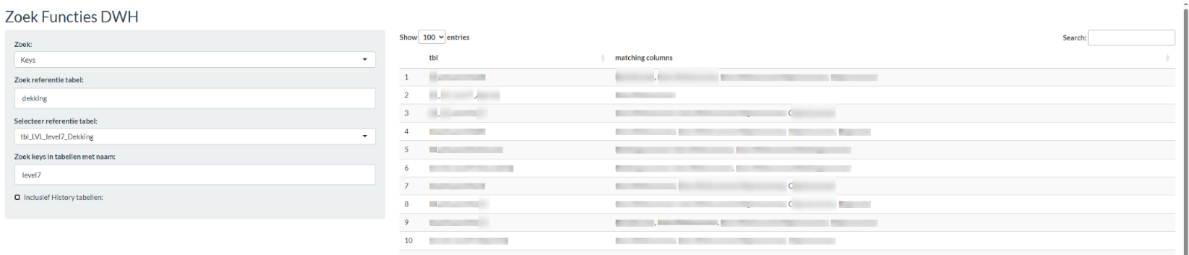

(results blurred due to privacy agreement)

**Replication research by competitor**

I was asked to replicate a study done by researchers from the other biggest competitor:

[Trends and Developments in Medical Liability Claims in The Netherlands "2279 (medirisk.nl)](https://medirisk.nl/wp-content/uploads/2022/10/healthcare-10-01929-2.pdf)

This report summarizes the statistics for medical liability claims in hospitals. I matched all the conducted analysis in this report with the available data from the department.

The goals were to provide the management with insight to how the organization compared to that report.

**Analysis expensive liability claims**

In this report I had used a dataset containing the most expensive claims to examine whether there were detectable patterns in costs. In the analysis below I considered type of claim (medical or vehicle), and age category, and the average duration until the case was closed. I used a custom visualization that depicts the sum of costs per age category and claim type in height of the blocks, and a color scale to represent the average cost.

From here it was evident that there was a decrease in average costs with older age categories for the medical claim types, but not for vehicle claim types.

Further, I analyzed attributes of cost components. Most often, the highest financial cost goes to compensating loss of the ability to work, but I assessed whether there more refined patterns of other components, using a heatmap to depict the share of each component per age category.

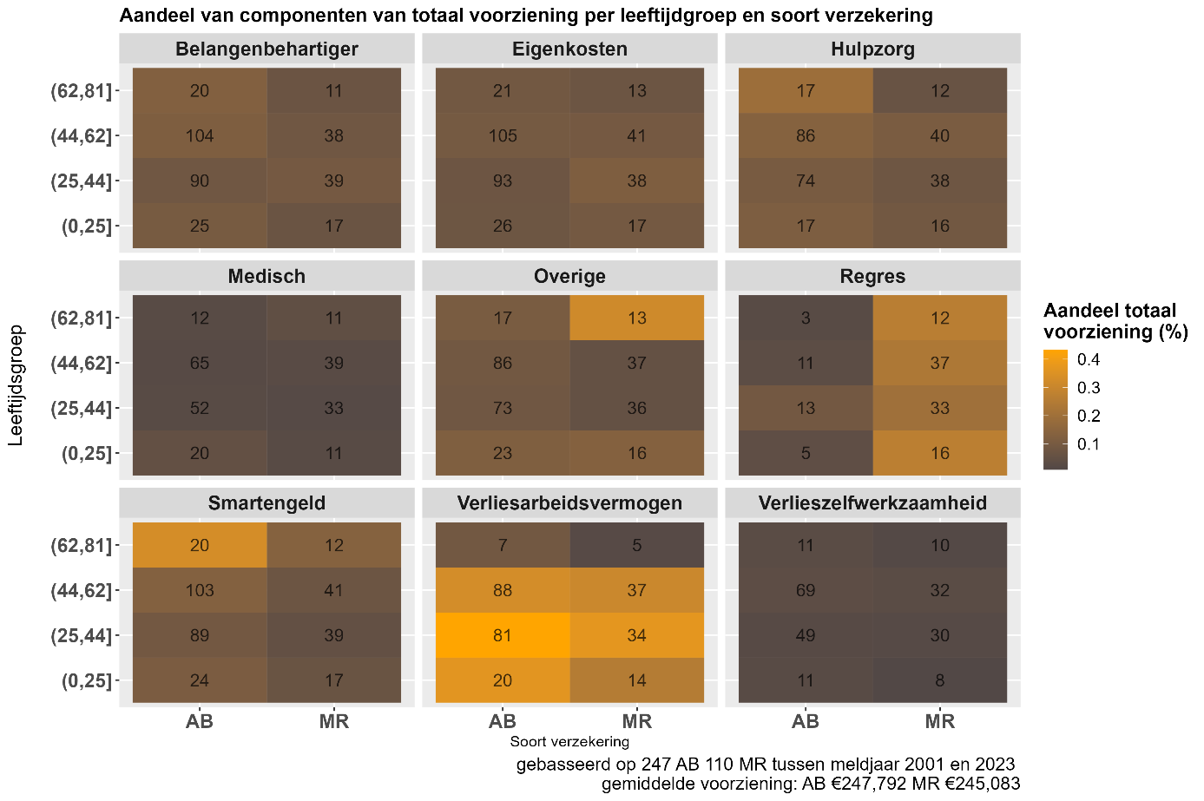

I had also included predictive methods to estimate how the share of each component changes with the increase of total cost. With these results, the actuary decided to use one of the components as a parameter to adjust certain pricing schemes.

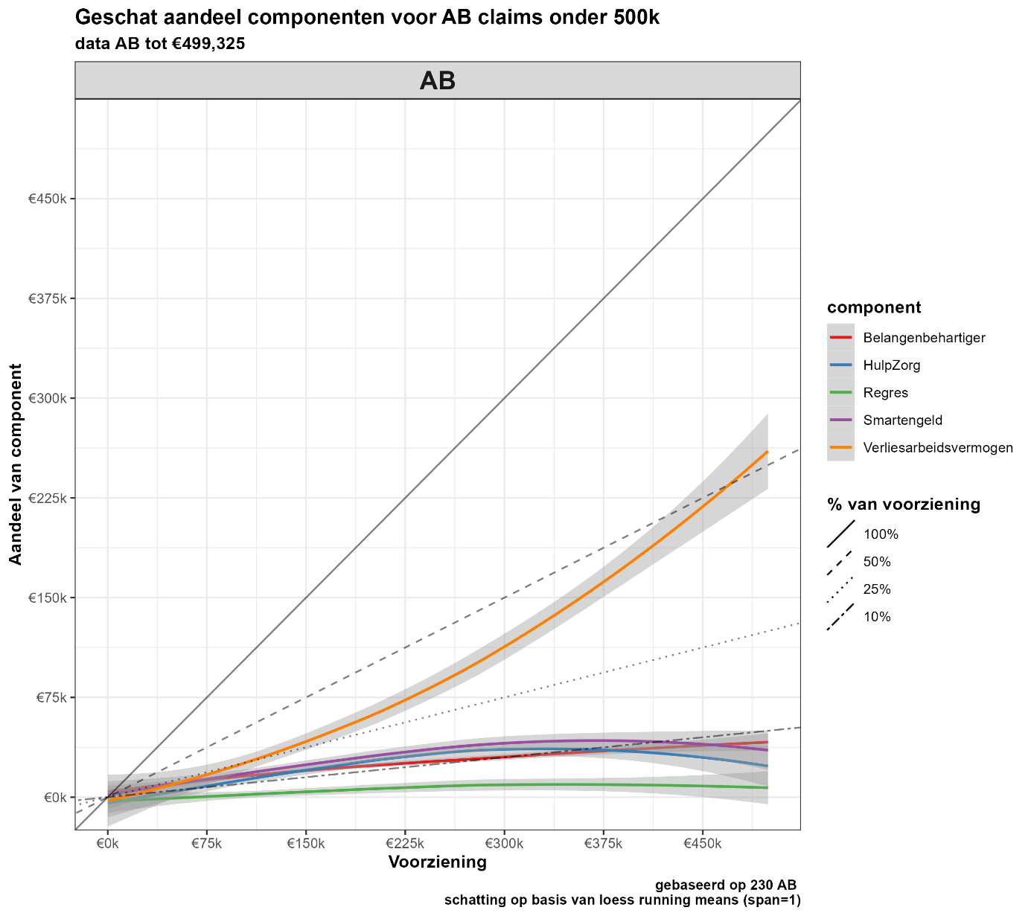

**Analysis of professions and injuries**

There any many differences between health care professionals in treatments and the goal of this analysis was to establish what the similarities and differences exist based on the available data.

The first step in this project was to examine a very extensive exploratory analysis on the quality of data for each profession (missing data, anomalies, validity). Using data on location of treatment (e.g. arm, legs, heart, etc.) I conducted a cluster analysis to illustrate the similarities between professions of involved treatments.

Another interesting insight I provided was the ratio between treated and injured body parts. If a patient gets treated for a specific body part, it does not always result in damage to that part of the body. Therefore, I visualized the ratio between treatment and injury for each profession. I automated this analysis to have recurring updates as the data was still insufficiently large to use for conclusive purposes. See below an example of the profession ‘general practitioners.’

**Recurring analysis increases in monetary reservations of claims**

When the department gets a new claim, the lawyers estimate whether it is necessary for the actuary to reserve an amount of money for this case. This is an ongoing jurisdictional process where updates are made on the amount reserved. We analyzed how many increases higher than 50K were made per year to assess whether lawyers were making good estimations for costs.

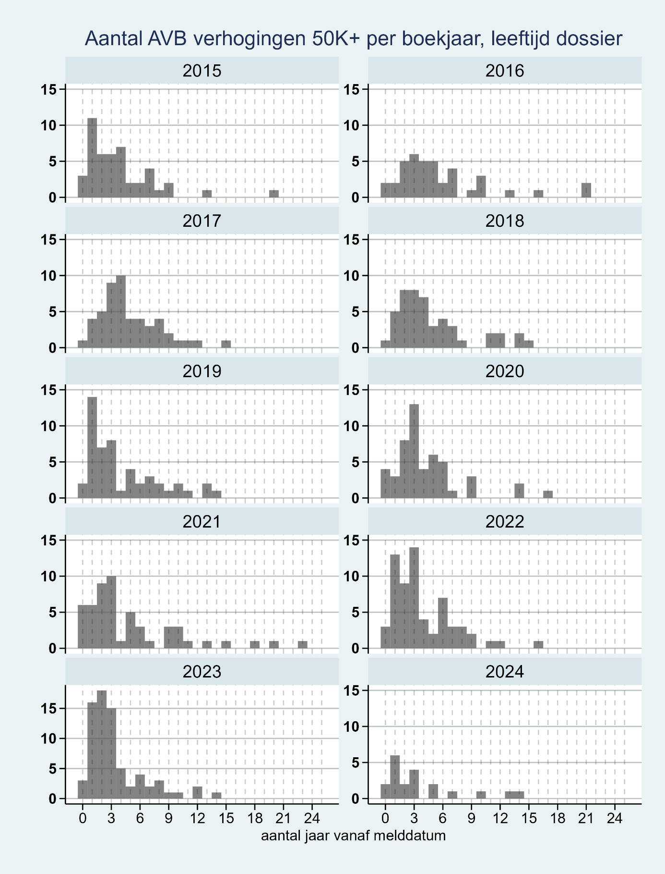

Here I also considered smaller increases to get a more comprehensive view.

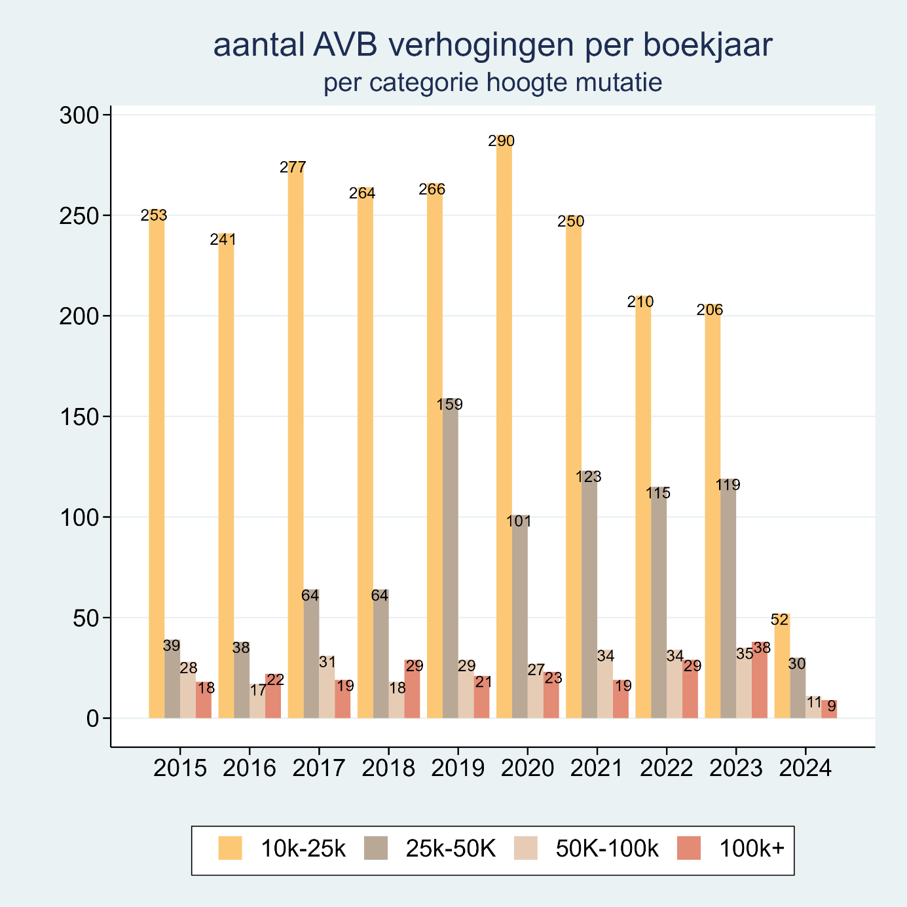

With this analysis, the management was provided insight into the quality of jurisdictional processes.

**Creating database schema’s**

Making database schema’s using real-time connections to the data warehouse.

With this, I documented the most important relationships of tables from our department.

**Creating data pipelines for reports**

*Weekly report providing the department of lawyers with information of contemporary cases:*

Loading information from a vast amount of tables using SQL language to efficiently load relevant data, transform data using R, and automating the process of storing the overviews into a neat excel file for the department to use. In this I had also designed a version in PowerBI. Impact: agenda-management for lawyers and steering handles for the management to distribute workload amongst employees.

*Pipeline for benchmarking customer risk indicators:*

Comparing insured clinics on the amount of claims made taking into account how many FTE are registered, how many years they have been insured, and the type of profession. Required numerous steps in transforming historical data from a vast amount of tables. End results: clear visuals on the performance of insured clinics, for the management to deliberate on and keep track of risky developments.

Portfolio Apprenticeship Gemeente Amsterdam

In my apprenticeship at the municipality of Amsterdam as a Junior Researcher, I contributed to reporting on municipal matters. Among them was one annual project that examine how safe citizens of Amsterdam feel in public transport. This report considered aspects such as type of transport, stops and causes of unsafe feelings. I worked within a small team of 4 other researchers. See below the link to the report.

[Monitor sociale veiligheid in het openbaar vervoer](https://openresearch.amsterdam/image/2018/3/19/2018_msvov_2017.pdf)